**Name : Punyaja Mishra  
Student Id : 0660001**

**COIS 2020H  
Assignment 1**

1. **Go to the repository at https://github.com/omalam/COIS2240Assignment1.git and and click Fork. Go to the new repository that GitHub will have created in your account, which will look like https://github.com/<yourname>/COIS2240Assignment1 and click "Clone or Download" and copy URI. In terminal, clone the repository whose URI you just copied**

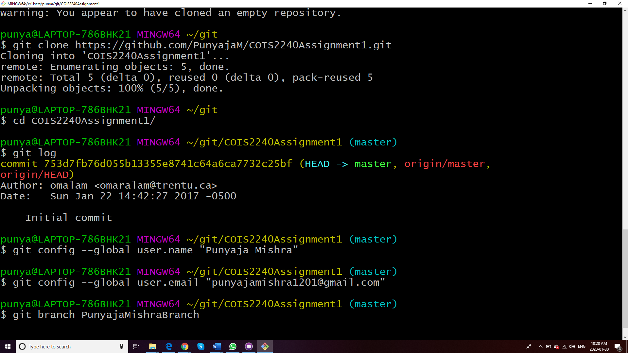

**2- Create a branch using the command line and name it your name. The branch name should be YourFirstNameYourLastName. For example, I can create a branch with my name OmarAlam. You should use the command $ git branch YourFirstNameYourLastNameBranch for this.**

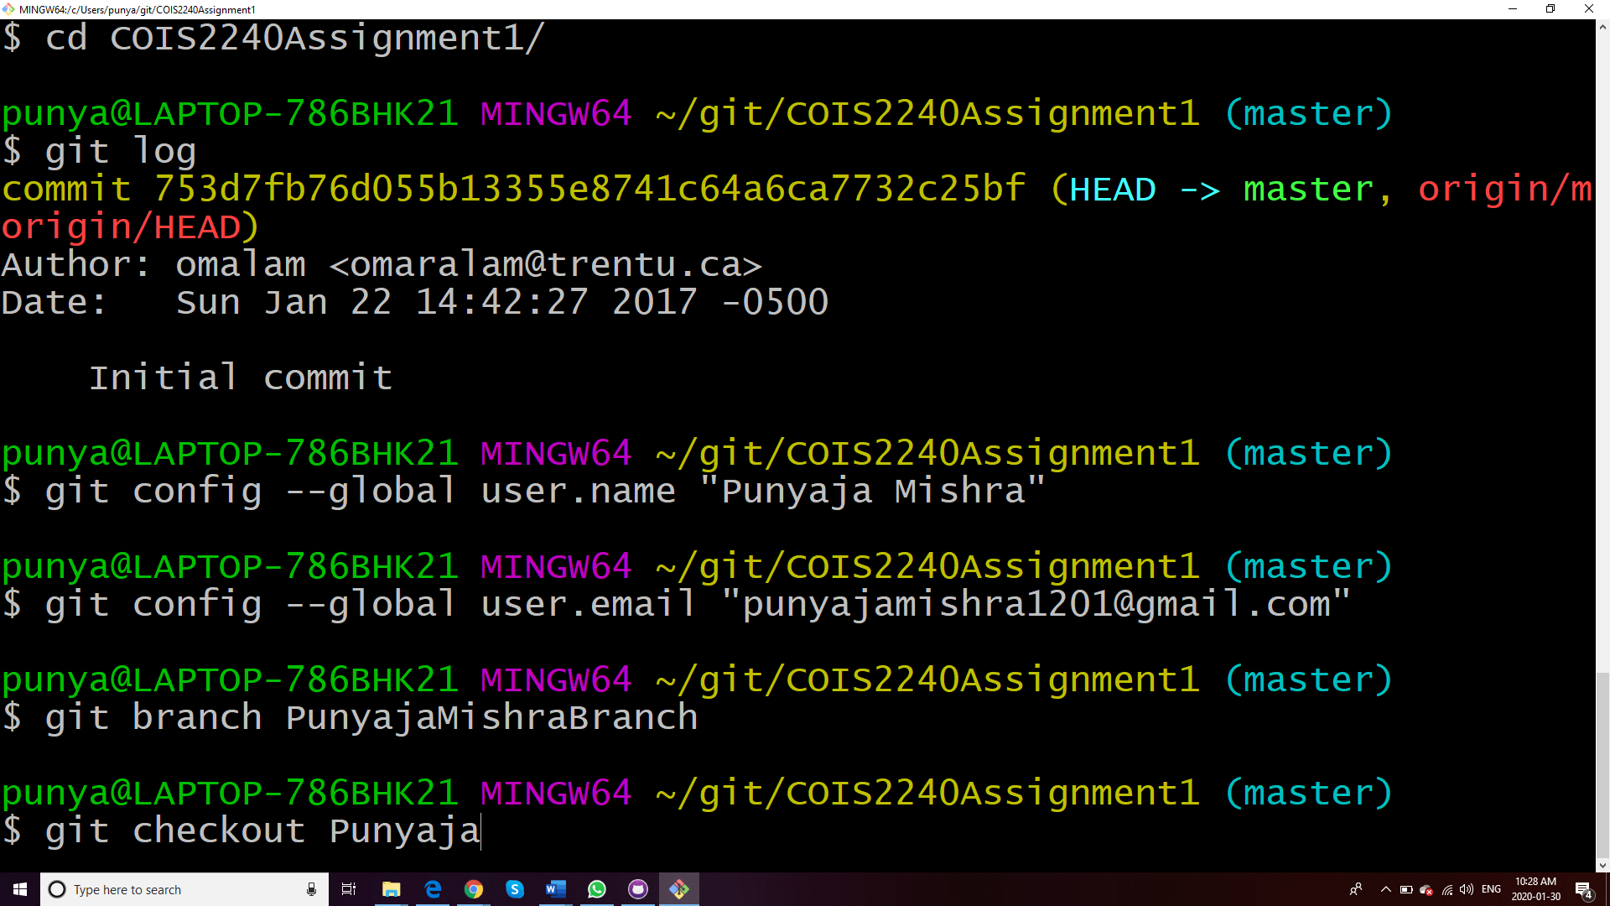

**3- Checkout your branch using the command $ git checkout YourFirstNameYourLastNameBranch**

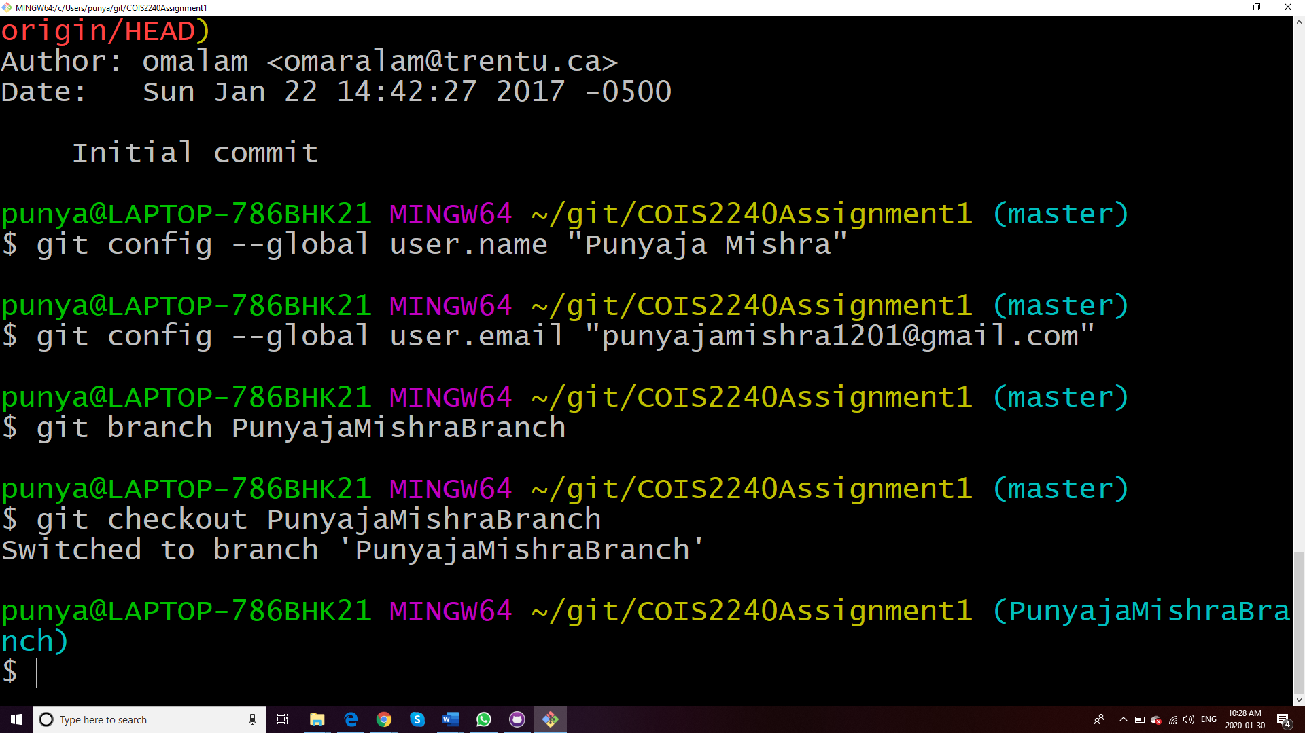

**4- Add an empty text file to your branch using the command $ git add YourFirstNameYourLastName.txt**

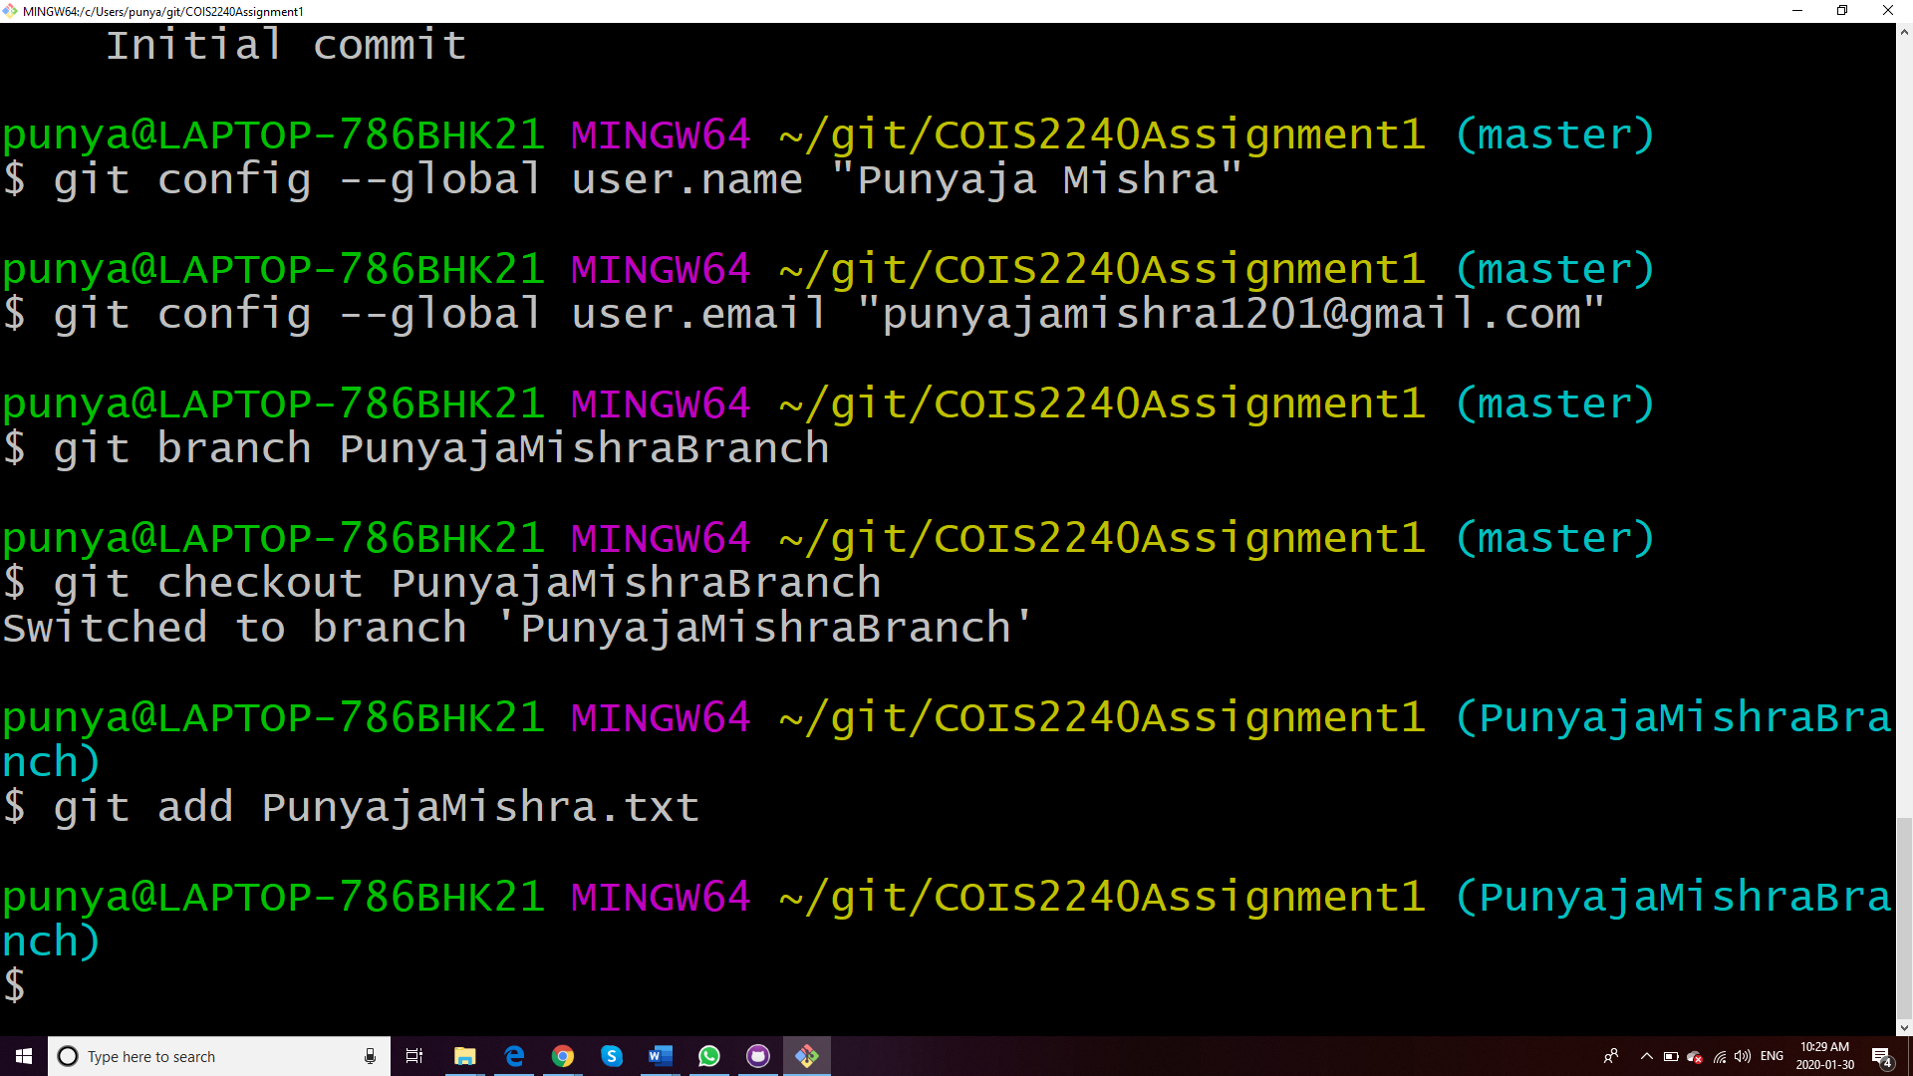

**5- Commit the file in the previous using the command $ git commit -m”My file for Question 1” YourFirstNameYourLastName.txt**

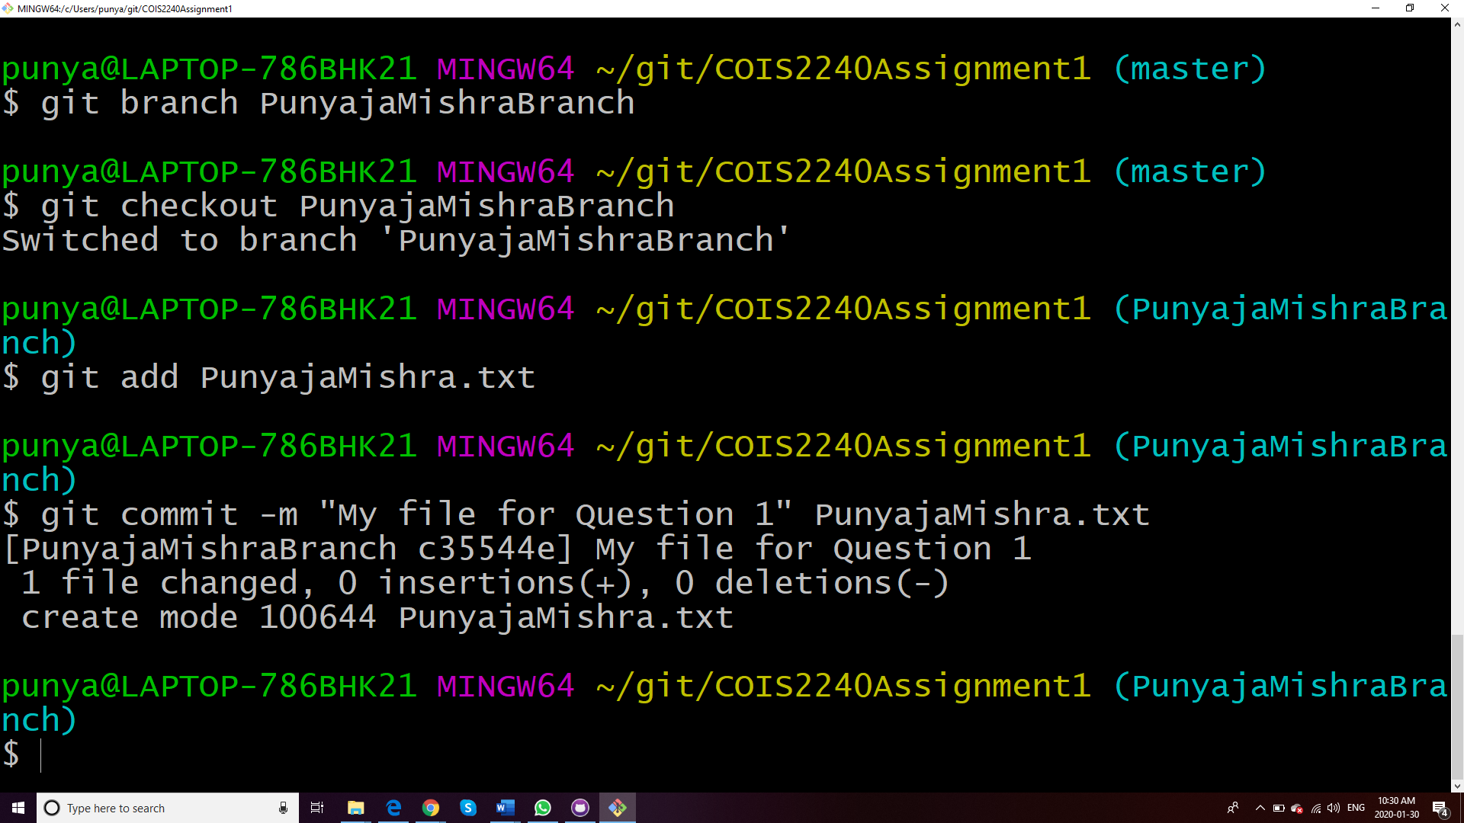

**6- Push your branch to the remote repository using the command $ git push -u origin YourFirstNameYourLastNameBranch**

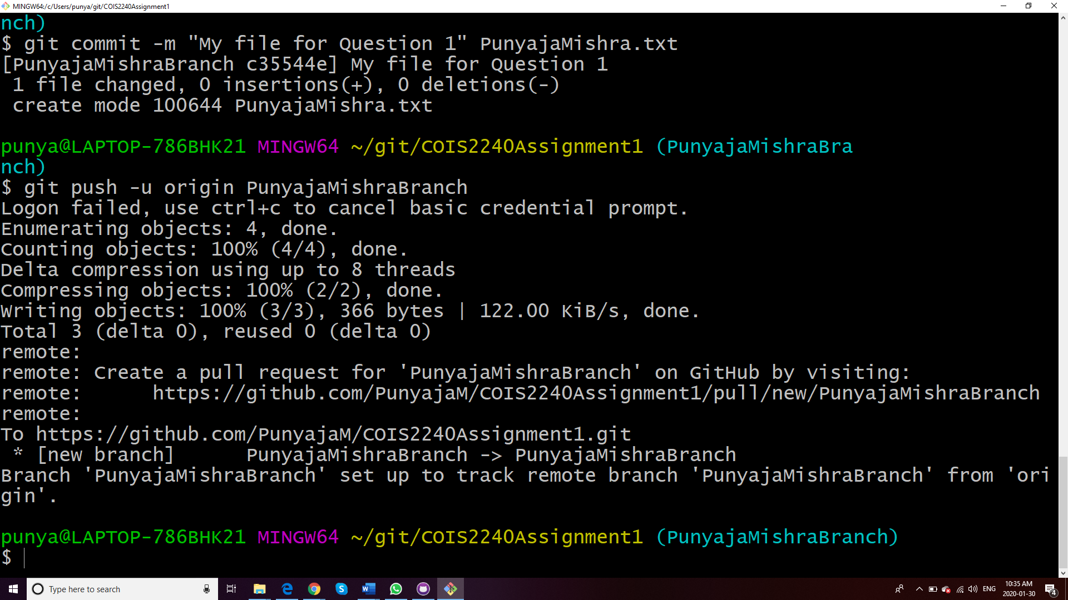

**Question 2: (a) An organization has three categories of employee: professional staff, technical staff and support staff. The organization also has departments. Each employee belongs to a department.**

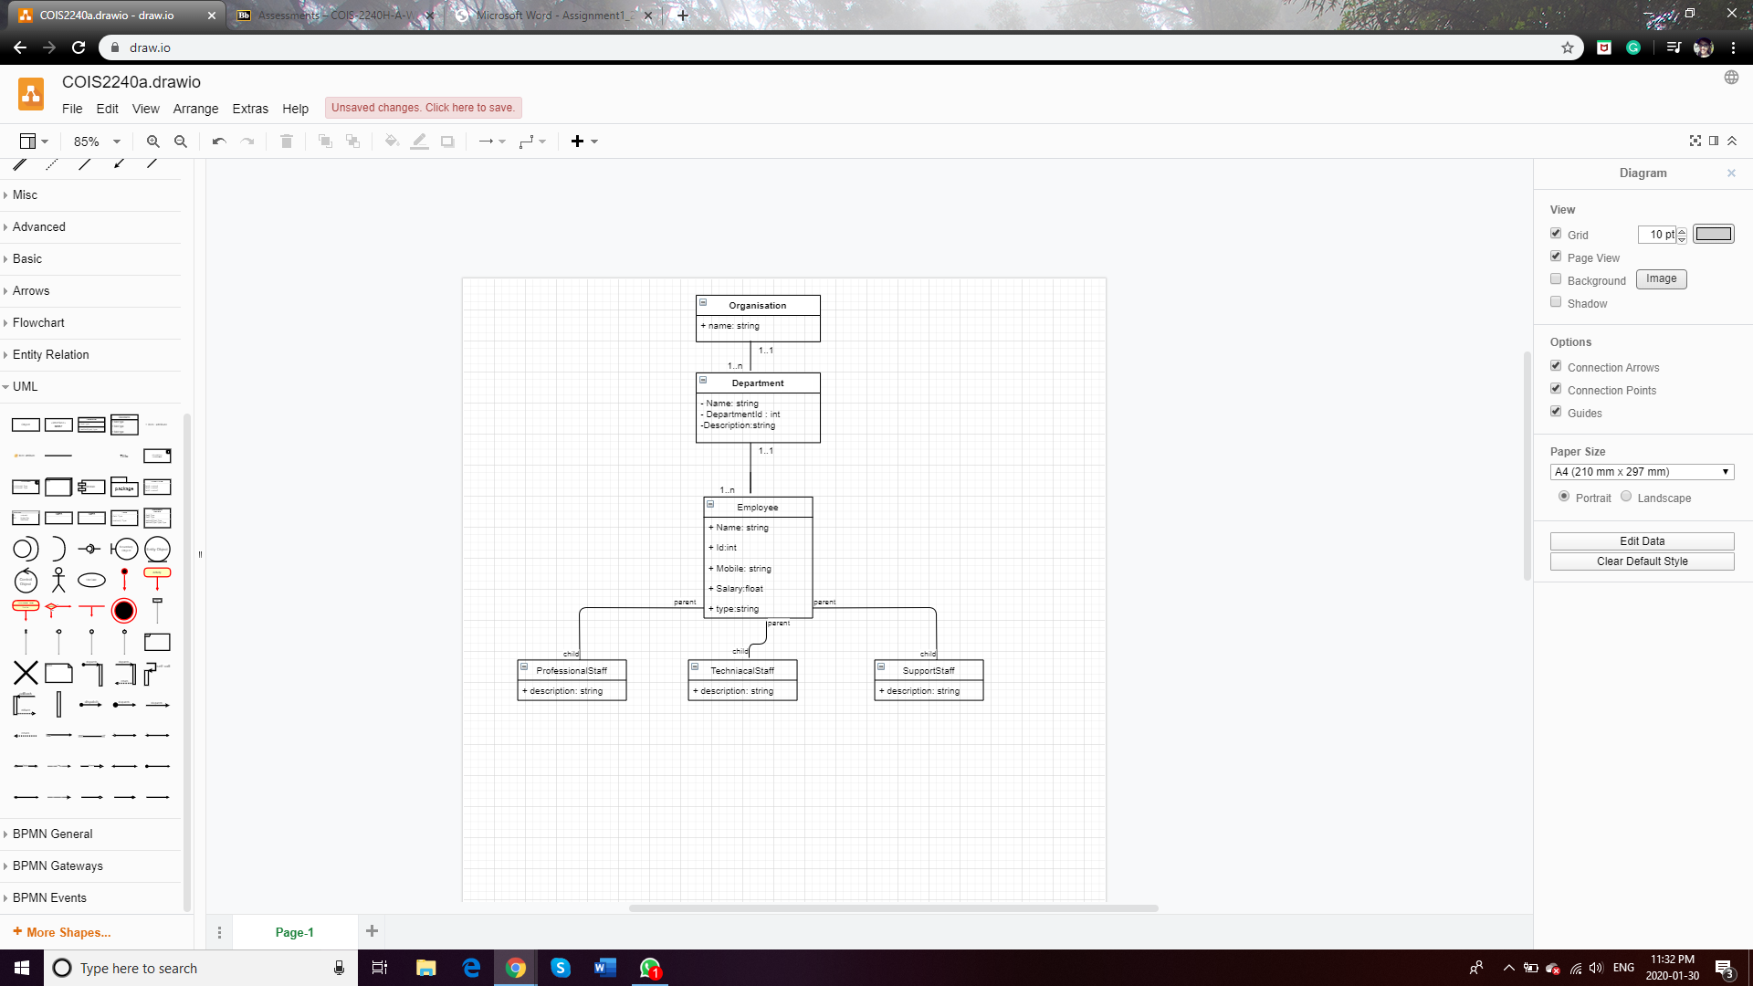

**(b) An employee can work on any number of projects and a project can be assigned to any number of employees. However, the employee has a position (role) in the project. The position has a description. Solve this problem with and without using an association class. Employees and Projects should have names.**

**Draw a class diagrams that captures the above scenarios. You may use any UML drawing tool. There are online UML drawing tools such as draw.io**

**With association**

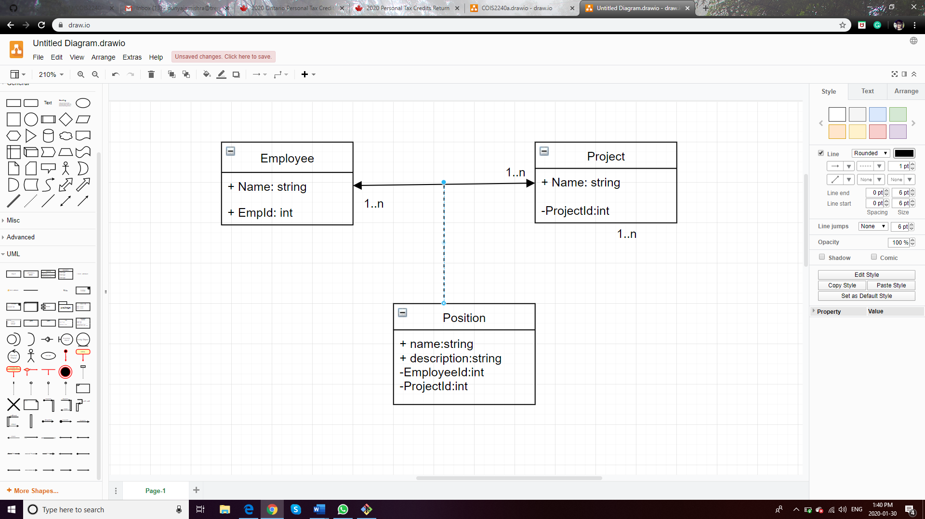

**Without association**

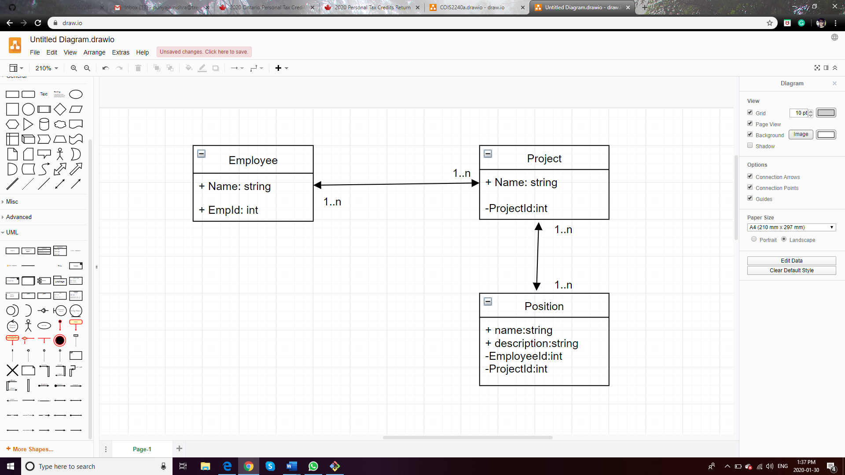

**Since, every project is going to have a position, in fact many positions, thus they are related. But also, that is the association class because that kinds of reduces the redundancy and the position has an employee and a project associated to it.**

**Question 3: Problem Description: Design a class named Triangle that extends GeometricObject. The class contains:**

**• Three double data fields named side1, side2, and side3 with default values 1.0 to denote three sides of the triangle.**

**• A constructor that creates a triangle with the specified side1, side2, and side3.**

**• The get and set methods for all three data fields.**

**• A method named getArea() that returns the area of this triangle.**

**• A method named getPerimeter() that returns the perimeter of this triangle.**

**• A method named toString() that returns a string description for the triangle. The toString() method is implemented as follows:**

**return "Triangle: side1 = " + side1 + " side2 = " + side2 + " side3 = " + side3;**

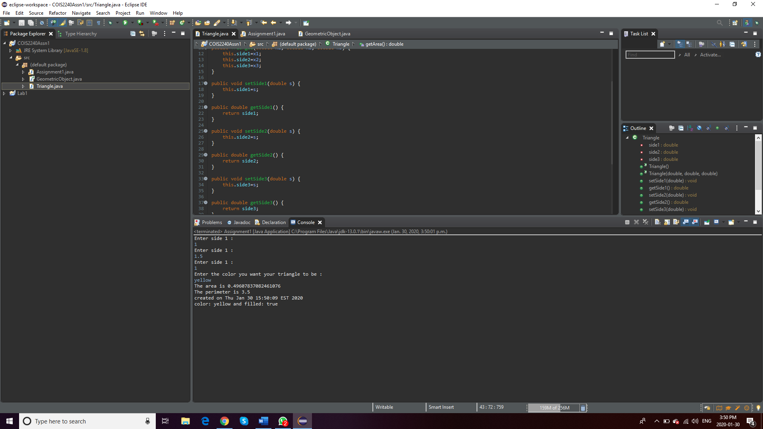

**The program runs.**

**We ask the user for first side, second side, third side and the color and print it out with area, perimeter and if or not it’s filled.**